Tutorial 4 – Restart button

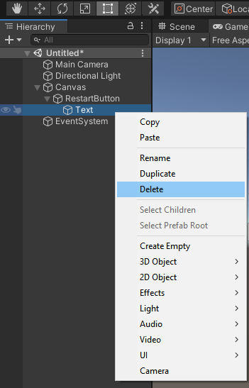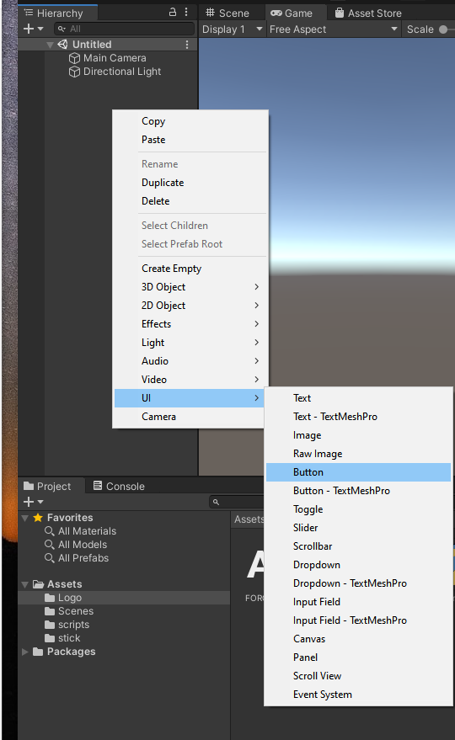To begin this tutorial, you must go into the hierarchy and add a button to use to restart the level.

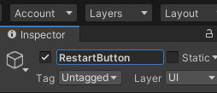Call this button ‘Restart button’

Click on the arrow next to the restart button in the hierarchy and if you do not want text for the button, delete it.

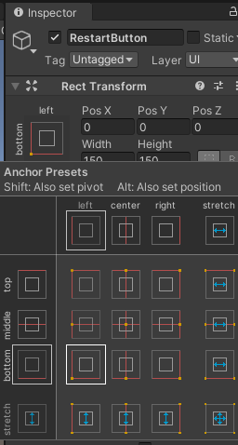

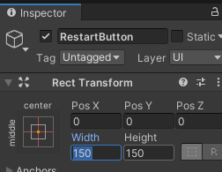In the inspector for the Restart button, change the width and height to make the button squarer shaped

To get the button to be positioned in the bottom left of the screen, click this and hold ALT and SHIFT and press the bottom left:

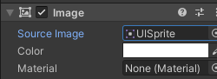If you want and have an image for the restart button, drag and drop it into the Source Image slot in the restart button’s inspector

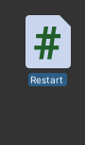Now we have the button positioned and scaled correctly and looking nicely, we need the button to work. For this we must create a script. Right click in the assets window, go to create - C# Script and call it ‘Restart’: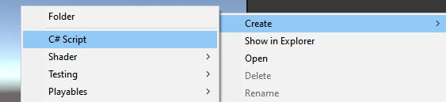

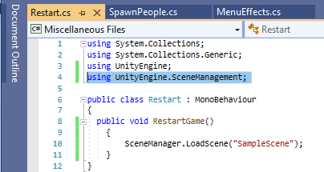Write this simple code – remember, change ‘SampleScene’ to your scene name/whatever your scene you want to load and never forget that when your coding with scenes to always write in this line:

ALWAYS write this when coding in scenes.

Drag and drop the Restart script into the restart button/the restart buttons inspector

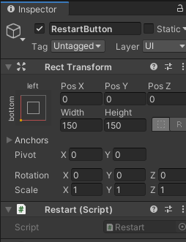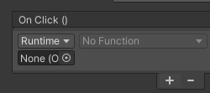 Next, we must add an On Click function to the button:

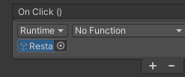

Drag and drop the Restart Button from the Hierarchy into the object slot

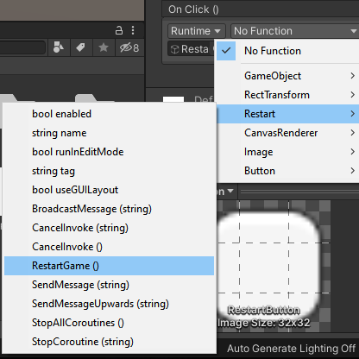Then, select a function for it, which will be to restart the game

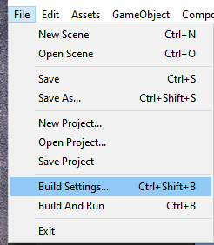Lastly, you must check that the scene you want to load is in the build manager – go to file, build settings:

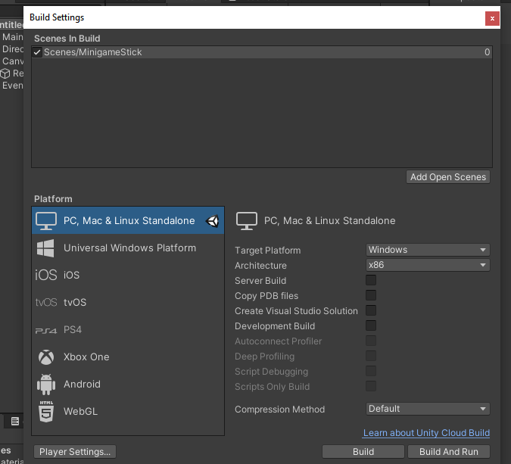Then check if your scene is in the ‘Scene in Build’ window. If it is not, just drag and drop it in there.

Now test out your reset button.